**Explain the Sovereign Credit Rating Model to me as briefly as you can.**

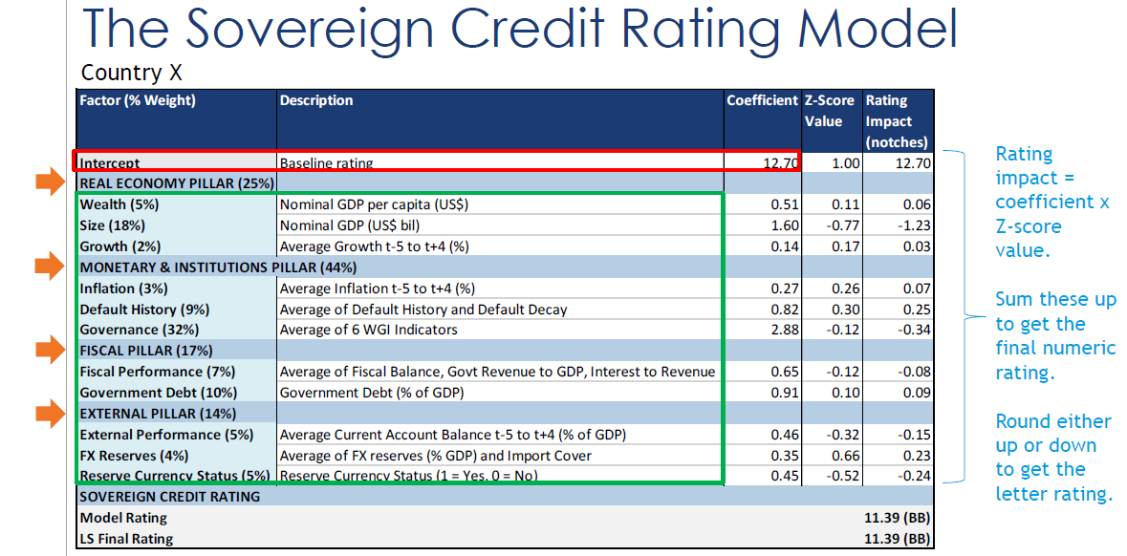

We use a simple linear regression model on a panel data set of countries.

The Model predicts a country’s credit rating on a numeric scale from 1 -22. 1 Being default, 22 being AAA rated.

11 Factors go into the model. All factors are Z-scored. In simple terms, think of this as a comparison of how a country stacks up against its peer group.

Starting from the top, each country begins with a baseline rating of 12.70 (somewhere between BB+ and BBB-).

Running down the table, each factor’s contribution to the rating is the factor coefficient multiplied by its z-score.

Sum this up and we get a final numeric rating.

This is then rounded to the nearest whole number, to arrive at the letter rating.

**I find the numeric ratings confusing. Please help!**

Sure, lets map these to the corresponding letter ratings that we are more familiar with.

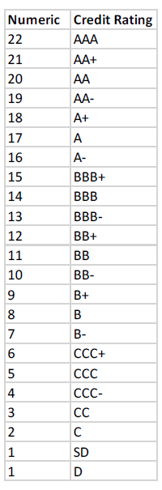

**I have been told to take a look at the model credit ratings of the countries I cover. Where do I go?**

Head to this website: <https://ls-sovereign-credit-rating-model.streamlit.app/>

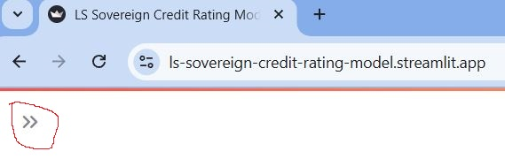

Sometimes the page appears blank but you might see this little dual arrow here. Click it! A little side bar should open up. Key in the **password:** Loomis1926!MS and hit login.

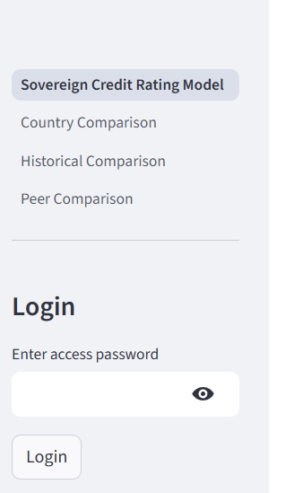

Congratulations you are now in! There are various pages on the sidebar for you to click on. The main one you will need to work on is Sovereign Credit Rating Model, which is displayed here. Hit the dual arrow to hide the side bar for a cleaner look!

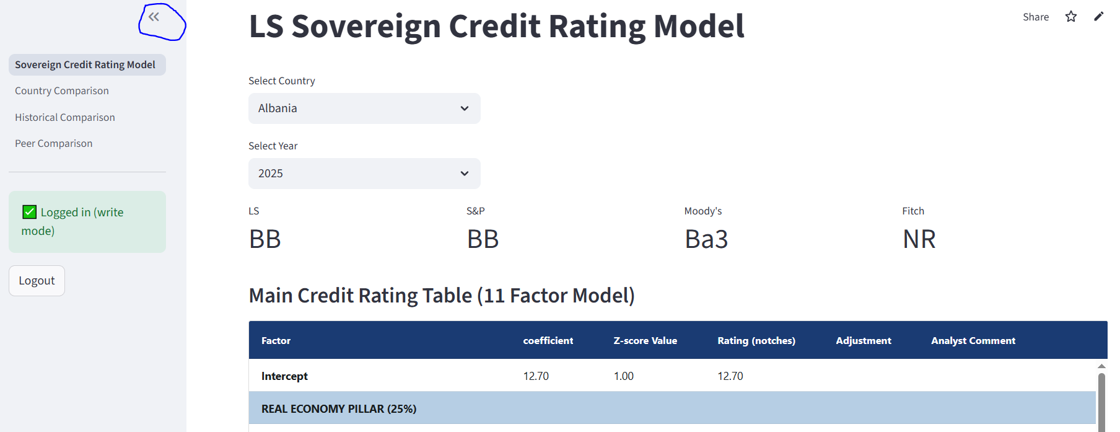

**Ok I have selected my country and the reference year in the top box, what do you want me to do next?**

You only have to look at the last two columns, “Adjustment” and “Analyst Comment”.

Scroll down the table and see which factors you would like to adjust.

In the Adjustment column you can key in a numeric adjustment for each rating factor. Note that a value of 1.0 corresponds to a one notch adjustment to the rating.

In the Analyst Comment column, give a brief justification for why you made that adjustment.

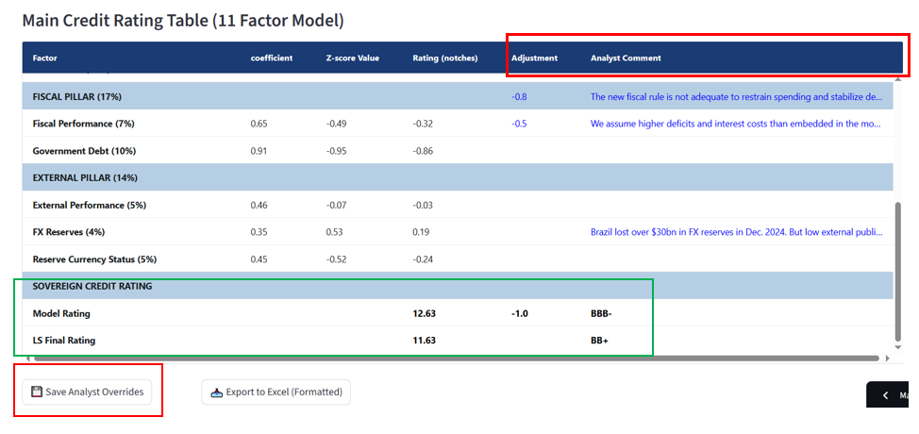

One you are happy with the adjustment you have made, hit the Save Analyst Overrides button below. Your adjustments will be saved, and your final rating will be updated.

**What if I am happy with the model output and do not see a need to adjust the rating?**

Lucky you! Just leave it as is and move on to the next country under your coverage 😊.

**What is the Supplementary Credit Rating Table below? Do I have to care about it?**

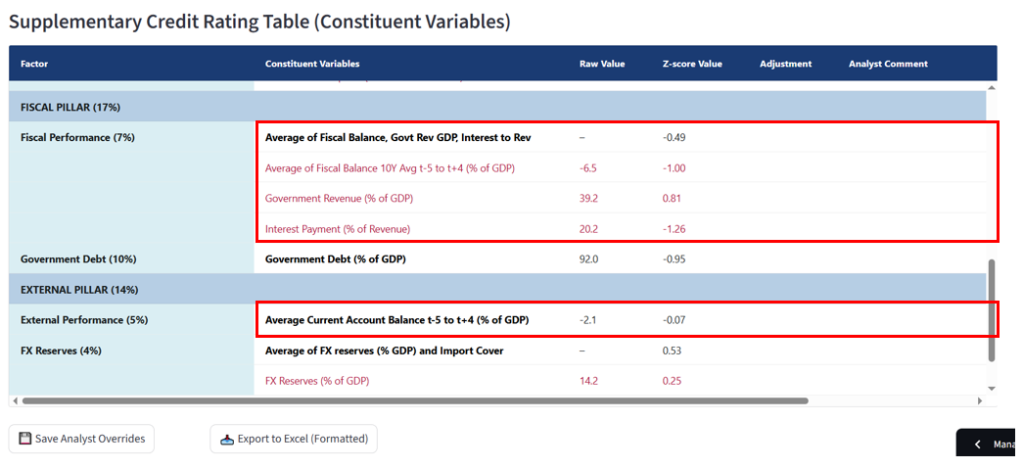

This table is meant to inform your adjustments in two ways.

Firstly, it shows you the raw value that goes into the model. For example, a current account balance of -2.1% of GDP (Z-score of -0.07).

Secondly, some factors like “Fiscal Performance” are “Blocked Up”. This table helps you to see what goes into such composite factors. For example, Fiscal Performance is the Average Z-score of 1) Fiscal Balance, 2) Government Revenue, and 3) Interest Payments.

**You may use this supplementary table to show your working if you wish.** So for example, if I made a 0.5 adjustment to Fiscal Balance and a 0.5 adjustment to Government Revenue, this would sum to a 1.0 adjustment to the Fiscal Factor.

If you hit “Save Analyst Overrides” for this table, your inputs in the Adjustment and Analyst column will be saved. **However, filling out the Supplementary Credit Rating Table will not change the final credit rating.** **For that you will have to return to the Main Credit Rating Table above to key in your adjustments and comments.**

The Supplementary Credit Rating Table is meant as a “working table” to aid you in making your adjustments in the main table.

**TLDR: You can safely ignore this table, if you find the Main Table sufficient for you.**

**I need help making adjustments to the model rating. What are some legitimate reasons for doing so?**

Generally, adjustments fall into two categories. Either 1) Some variables are important but not captured by the model or 2) Data is stale either because of update frequency or significant developments.

The table below provides a handy guide on common reasons why certain factors might be adjusted.

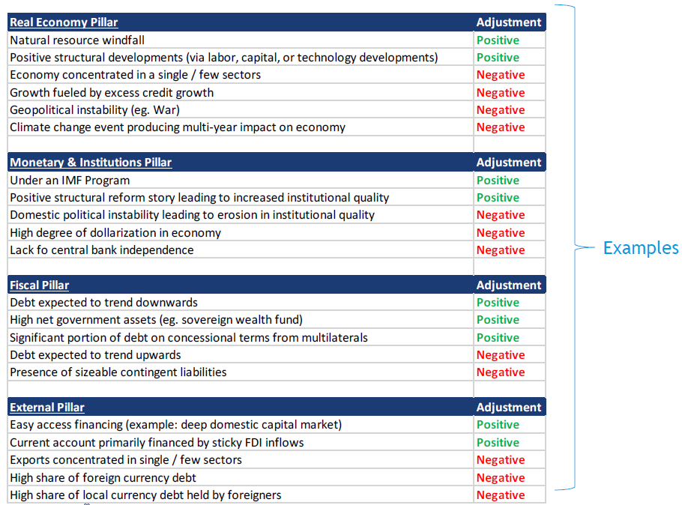

**I need peer and historical context to better inform my adjustments. Please help!**

Got you covered! That is what the next three pages (located on the side bar) are for.

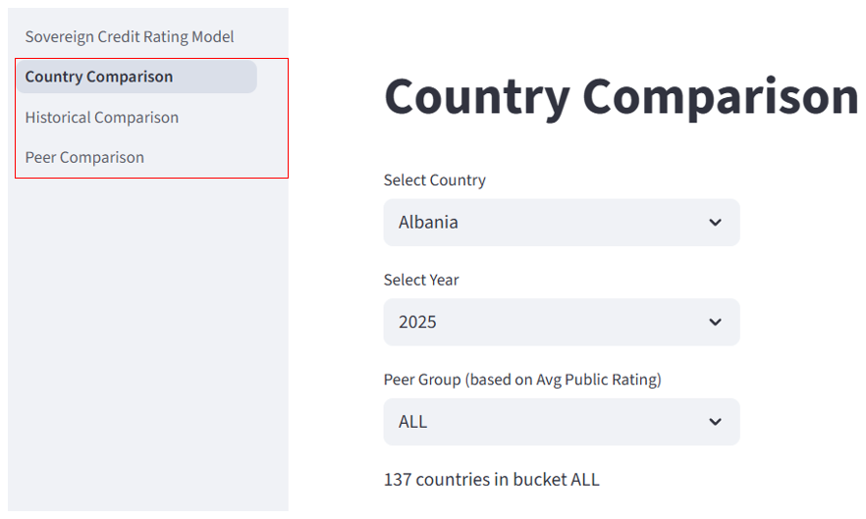

Click into them and explore!

These are also very useful to quickly get up to speed on a new country you have never covered before.

**I am working on a time sensitive new issue and need to show my credit rating rationale in my note. How can I do this quickly?**

Simple. Just hit the “Export to Excel” button below your table, and download the excel file. In it, you will see a nicely formatted presentation ready table that you can just copy and paste into your reports.

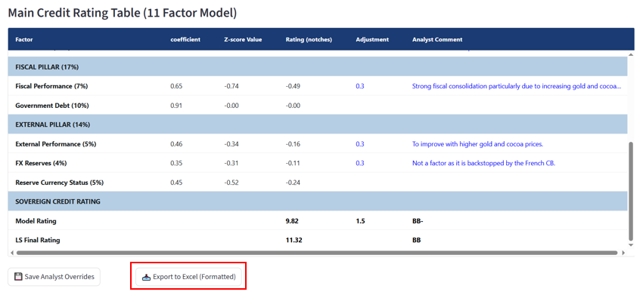

**How do I get my Credit Rating into ERV? What does shifting the “dots” mean? How do I do it?**

Slow down there! Let’s break it down one step at a time!

**To change your credit rating in ERV,** simply find your country, and then click on the rating in the LsQ column, a dropdown should appear where you can select your letter rating. Note that you will have to submit a short write up to justify the change.

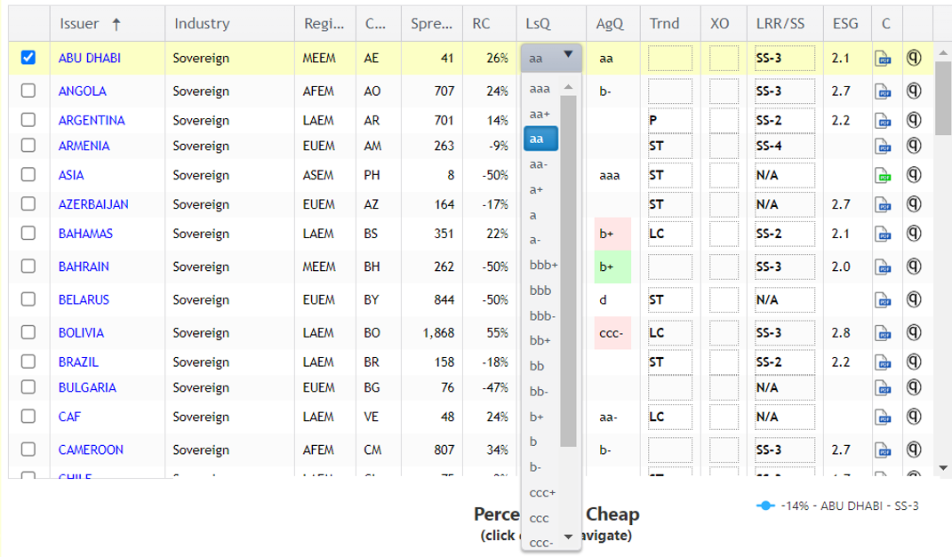

**Shifting the dots** means dragging your country dot to the left or right on the ERV plot.

**This is typically done when you want to be even more precise in your letter rating.** This is what the numeric rating output from our credit rating model allows us to do.

**As an example**, 13 corresponds to BBB rating. If a country has a numeric score of 13.44, this gets rounded down to 13, which gives it a BBB- rating. We can then say this is a “Strong” BBB-. Correspondingly if a country has a numeric rating of 12.6, this gets rounded up to 13, which also gives a BBB- rating. However, in this case, we say this country is a “Weak” BBB-.

**To do this in ERV, just drag your country dot left or right** within the rating bucket.

So for example, if a country (say Paraguay) has numeric score of 13, it would see right above bbb-, i.e a middle bbb-.

If a country has a numeric score of 12.53 (say Costa Rica), it would be placed towards the right side of the band, as it is a weak bbb-.

And if a country, has a numeric score of 13.48 (say Oman), it would be placed on towards the left side of the band, as it is a strong bbb-.

To note, that stronger goes to the left, as the ERV x-axis goes from AAA on the left to C on the right. That is to say, credit rating decreases along the x-axis in the ERV plot.

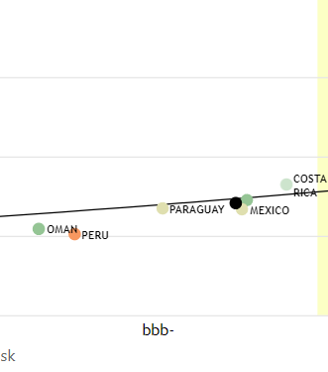

**I need more help working out how much to shift the dot by! What do I do?**

Download the “LS_rating.xlsx” file in the about page of the website. (the same place you found this guide).

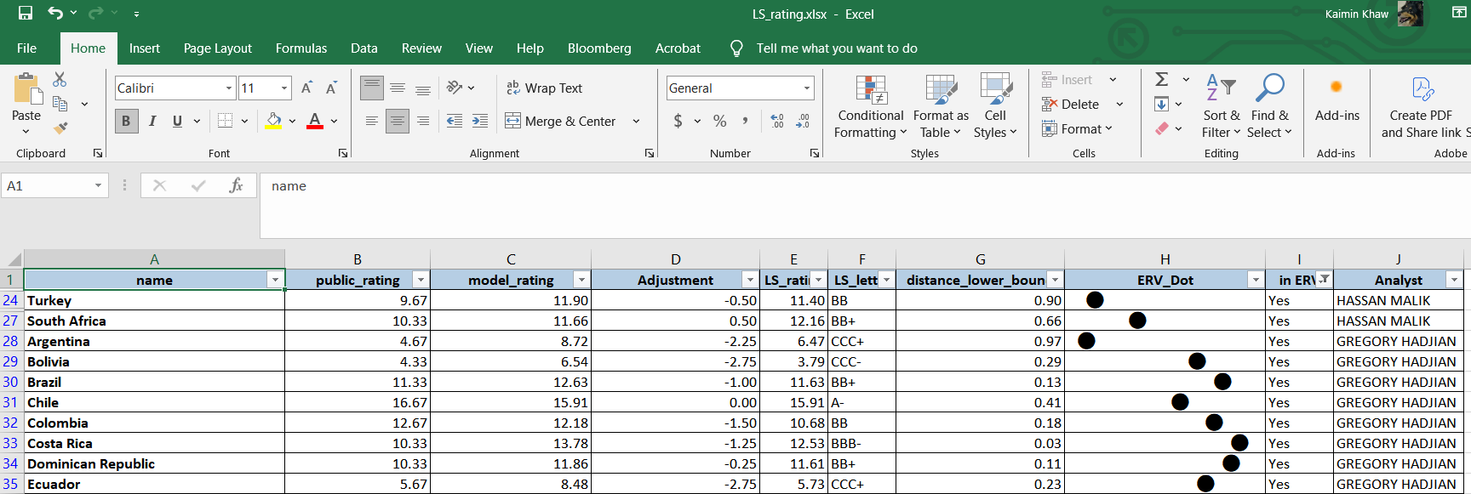

Use Column I “in ERV” to filter out countries that appear in ERV.

Look at Column H “ERV_Dot”, where we have already calculate for you where to shift your dot within its rating bucket in ERV.

Left side = Stronger, Right side = Weaker.

**What if my country is not in ERV?**

If your country has sovereign bonds denominated in USD, please approach Bernardo to get it added.

If your country does not have sovereign bonds denominated in USD, congratulations on avoiding original sin 😊. No need for you to do anything in ERV!